1. Design and Configuration of BUS Topologies using Packet Tracer.

Bus Topology using Hub:

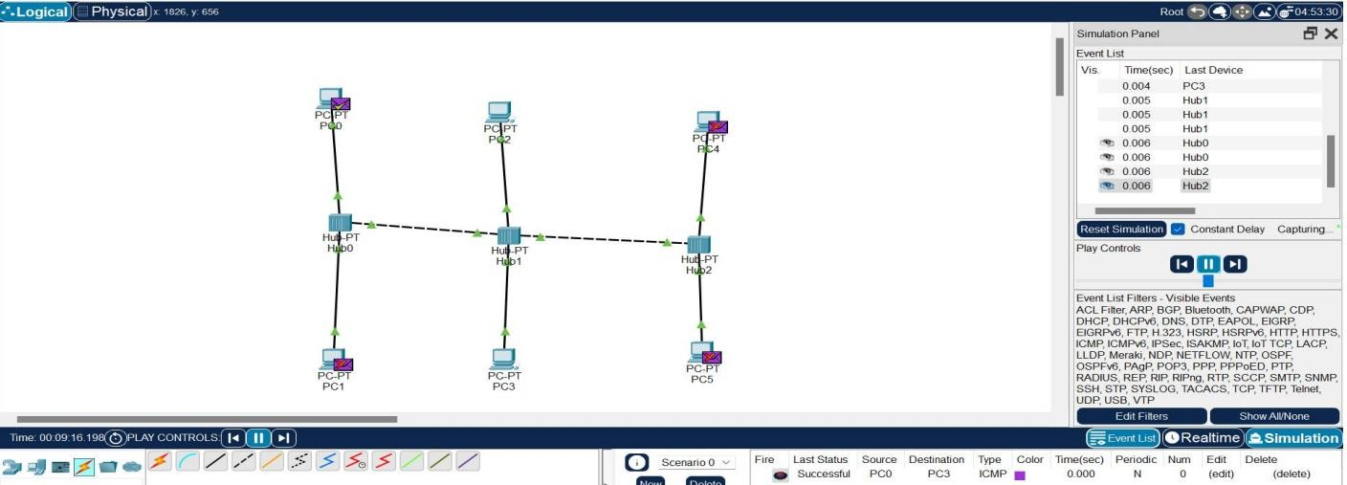

Bus Topology using Switch:

